Project ID: 00087782
Parliamentary Support in Pakistan

Annual Progress Report
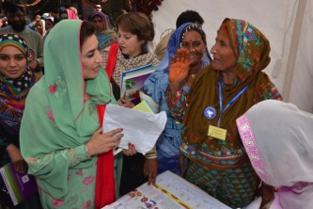
January – December 2014
Photo credits and caption

Project Snapshot

Date: |  |  | 5th January, 2015
Award ID: |  |  | 00076330
Project ID: |  |  | 00087782
Project Title: |  |  | Parliamentary Support in Pakistan (PSP)
Project Start Date: |  |  | October 1, 2013
Project End Date: |  |  | December 31, 2017
Implementing Partner: |  |  | UNDP
Responsible Parties: |  |  | UNDP
Project Budget (all years): |  |  | Total Project budget as per Project Document: US$ 8.3 (Million)
Core Resources:
UNDP (US$ 0.8 Million)
Non-Core Resources:
Project Brief Description and Outputs

The Project "Parliamentary Support in Pakistan" aims to assist the National Assembly, the Senate, and the four Provincial Assemblies to build the capacity of their core functions (law making, representation and oversight) and increase parliamentary engagement in development processes, particularly the MDGs and the post-2015 Agenda. Phase IV of the project (January 2015 – December 2017) will also pursue a more issues based approach, sharpening the focus on increasing women’s participation in political process and developing legislative expertise in critical fields such as climate change and women’s empowerment. It will also conduct activities designed to establish and strengthen mechanisms which increase citizen engagement with legislative processes in order to support broader efforts designed to nurture the emergence of more inclusive governance processes in Pakistan. A revised set of outputs have been developed for Phase IV. This followed an extensive consultation exercise with key stakeholders at the federal and provincial level. The subsequent set of outputs that have emerged are more relevant to the institutional development needs of each of the legislative institutions with which the project is engaged. For the purposes of this report the Phase III outputs are listed below and the subsequent pages details the progress made against these objectives.
Output 1: Governance structures of National Assembly and Senate more effectively perform their mandates and successfully conduct strategic institutional development.
Output 2: Independent and professional Parliamentary Administration support the work of the National Assembly and enhance capacities to provide legislative services to Members and committees.
Output 3: Selected National Assembly and Senate committees empowered to more effectively scrutinize legislation and executive action, and promote public input into their work.
Output 4: Increased cross- party co-operation between men and women parliamentarians on issues of concern to women, and the inclusion of gender considerations in the work of parliamentary committees.
Output 5: National Assembly engage with the people of Pakistan more transparently and effectively.
Output 6: Provincial Assemblies more effectively oversee progress in achievement of MDGs, gender equality and devolution processes; and promote public input into their committee work.

Overall Project Quality Rating (mark on the scale of 1 to 5 as per the following criteria):
Exemplary (5)  ***** | High (4)  **** |  |  | Satisfactory (3)  ✔ | Poor (2)  ** | Inadequate (1)  *
All outputs are rated High or Exemplary | All outputs are rated Satisfactory or higher, and at least two criteria are rated High or Exemplary |  |  | One output may be rated Poor, and all other criteria are rated Satisfactory or higher | Two outputs are rated Poor, and all other criteria are rated Satisfactory or higher | One output is rated Inadequate, or more than two criteria are rated Poor
Budget 2014 |  | US$ 800,000.00
Expenditure 2014 |  | US$ 794,466.00
Delivery % |  | 99.31%

Contents

- Introduction

- Situation Analysis

- Project Performance and Results
  - Contribution toward Country Programme Outcome
  - Achievement of Project Results/Outputs

- Lessons Learnt

- The Way Ahead/Key Priorities for 2015

Annex 1: AWP Based reporting matrix
Annex 2: Annual Project Quality Assurance Assessment

Acronyms

APR | Annual Progress Report
AWP | Annual Work Plan
CBP | Capacity Building Program
CO | Country Office
CSOs | Civil Society Organizations
IPU | Inter Parliamentary Union
NA | National Assembly
Pas | Provincial Assemblies
PIPS | Pakistan Institute of Parliamentary Services
PRB | Project Review Board
PSP | Parliamentary Support in Pakistan
SELP | Strengthening Electoral and Legislative Support
STP | Staff Training Program
UNDP | United Nations Development Program
WPC | Women’s Parliamentary Caucus
MDGs | Millennium Development Goals
SDGs | Sustainable Development Goals
DPU | Development Policy Unit
TFs | Task Forces
SP | Strategic Planning
PD&R | Planning, Development and Reforms
HR | Human Resources
VAW | Violence Against Women
IMF | International Monetary Fund
AF | Accelerated Framework

- Introduction

United Nations Common Country Programme (2013-2017) focuses on supporting Pakistan to reach its national and provincial development targets including the MDGs (and post-2015 MDG goals) as well as ensuring the rights vested in the constitution and international conventions to which the country has acceded. Specifically, one of the key strategic objectives aims to strengthen the capacity of institutions to become more democratic and accountable and increase their engagement with civil society, media and academia. A priority is also to accelerate legislation and development of mechanisms to monitor the elimination of discrimination against Pakistani women and girls.

Building on this framework, the Project "Parliamentary Support in Pakistan" (which began in 2004) assists the National Assembly, the Senate and the four Provincial Assemblies of Pakistan to build the capacity of their core functions (law making, representation and oversight) and increase parliamentary engagement in development processes, particularly the MDGs and the post-2015 Agenda. The project also works with the legislative bodies to promote dialogue and participatory processes. Building institutional capacity to promote a more inclusive system of governance with effective oversight powers is critical to ensuring sustainable development pathways. Absent such institutions and Pakistan is unlikely to meet its human development targets.

2014 was a year of transition for the project. A new Chief Technical Adviser was appointed in June 2014 which shifted the focus to designing a new program strategy for Phase IV that is firmly aligned to the institutional development priorities of the Federal and Provincial Assemblies. To inform program design in this regard, needs assessments and consultations were conducted with legislative institutions to ascertain the scope and nature of technical assistance that would be required up until December 2017.

In consultation with Senior Management and the CTA, it was agreed in June that the project would not strictly follow the targets set out in the 2014 AWP. Not only were insufficient technical and financial resources available to achieve the targets that had been set but also the AWP was deemed to be out of sync with the emerging institutional development priorities of legislative institutions in Pakistan. It was agreed that the CTA would pursue specific activities that would lay the foundations for core programming under Phase IV – developing Strategic Plans for the Women’s Parliamentary Caucuses and the MDG Task Forces.

Significant achievements were consequently accomplished in 2014, laying the basis for further progress over the next three year. Women’s caucuses were established in the Provincial Assemblies; an MDG conference on strengthening legislative engagement with the MDG process was hosted by the project in partnership with the National Assembly; MDG Task Forces were established in Provincial Assemblies and a series of capacity building initiatives were undertaken to strengthen MPAs understating of Rules of Procedure, budget processes as well as legislative oversight of development agendas.

Since being established through the support of the project, all four provincial women caucuses have developed draft Strategic Plans. Each Strategic Plan, tailored to the specific needs and conditions of each province, maps out legislative agendas for strengthening women’s empowerment and gender equality. The women caucuses have already started influencing gender-based legislation in their respective provincial assemblies. In Sindh, for example, a Bill against child marriage has already become an Act of the Assembly. Furthermore, in Balochistan, the Bill against domestic violence has already become a law.

Another milestone achieved during 2014 was the establishment of a permanent Senate think tank called the ‘Senate Forum for Research and Policy’. The forum is mandated to devise a research agenda for the Upper House based on its business and issues confronting the House. This is expected to enhance the quality of research and legislative drafting in the House through the involvement of sitting and former Senators to supervise the process.

- SITUATION ANALYSIS

Legislative institutions around the world are constantly exploring how their core functions – representation, oversight, and law making – can be improved. This is partly being driven by the changing world in which we live. The proliferation of media channels over the past decade through the growth of cable television, the internet, social media platforms and mobile technology, offers citizens a wider range of information options than were available to previous generations. The political effect of this phenomenon is not only an increase in political awareness but also growing demands, regardless of the country context, for more responsive democratic institutions. As a consequence, even parliamentary institutions in developed countries are having to implement reforms to enhance the effectiveness of their core functions in the eyes of the electorate.

Strengthening the core functions which define parliamentary activity is vital, not only for improving governance standards and service delivery, but also the confidence of citizens in parliamentary democracy. Human development challenges and rule of law issues are difficult to address in the absence of efficient and effective legislative institutions. As the leading representatives and law making bodies in any democracy, legislative assemblies have the potential to design and implement legislative agendas capable of meeting people’s basic needs and promoting social cohesion among the people they serve. Achieving this potential requires ensuring legislators have the resources, knowledge and skills to perform their tasks to the optimum level.

In the context of Pakistan, much work remains to be done to ensure that legislative institutions are able to effectively exercise their democratic mandate and achieve their democratic potential. Significant challenges remain: strengthening the research and technical capacities of Secretariats; developing the policy knowledge of MNAs/MPAs (specifically in relation to MDGs); improving the oversight capabilities of committees; making legislative institutions and legislators more responsive to citizens; and strengthening the role of women in legislative processes.

In addition, developing the technical and institutional capacity of the Provincial Assemblies to improve their respective legislative performances, has become a critical governance challenge following the adoption of the 18th Amendment. The devolution of key ministries to the provincial level has raised expectations about service delivery and underlined the need to strengthen the legislation and oversight capacity of provincial assemblies in order to meet the legislative demands placed on them by the devolution process. The achievement of development goals, in particular the Millennium Development Goals, will now largely depend of the ability of the provincial authorities to effectively implement devolved responsibilities. This requires provincial assemblies creating legislative and policy frameworks that remove barriers to accomplishing development goals.

To progress in this direction provincial legislators require, among other things, a fully resourced Secretariat and to be empowered through a comprehensive technical training program covering issues such as rules of procedure, laws, budgetary processes and financial oversight and, particularly for members of Standing Committees, knowledge development of specific policy areas.

- Project Performance and results

  - Contribution towards Country Programme Outcome
CPAP Outcome:
The capacity of institutions to be more democratic and accountable is strengthened, including, inter alia, the engagement of civil society organisations, media and academia.

Indicator(s):  The capacities of the member of parliament enhanced to effectively engage in dialogue and debate on core development, nation-building and/or peacebuilding issues  Enhanced participation of marginalized groups in parliament (e.g. women, youth, minorities) | Baseline:  UNDP/IPU Mission Report 2013 | Target(s):  Improve Women-specific legislations  Build capacity of the Members of Provincial Assemblies on parliamentary procedure and rules of business | Achievement(s):
Description of output level high/outcome level results achieved in 2014:

  - Progress towards Project Results/Outputs

Project Output I:
Governance structures of National Assembly and Senate more effectively perform their mandates and successfully conduct strategic institutional development.
Indicator(s):  Speakers’ Conference: number of recommendations adopted  Council of Chairpersons: number of recommendations adopted and progress in implementation, regularity of meeting  Parliamentary integrity: recommendations for Code of Ethics/Conduct adopted |  | Baseline:  Speakers’ Conference a conventional forum that meets less than once a year on average and lacks structured operation.  RoP provides for Council of Chairpersons but lacks structured operation.  No. Code of Ethics/Conduct in place for MPs or staff. |  | Target(s):  Speakers’ Conference functioning regularly holding at least 2 meetings a year.  Council of Chairpersons established.  Parliamentary Staff’s and elected representatives’ focus is to make parliament a more independently working institution through awareness raising sessions. |  | Achievement(s):  Support to Speaker’s Office at SAARC Conference; Provision of Kiosk machines for NA; Bill-Tracking Software for Senate; Wi fi facility to Senate.
Description of output level results achieved in 2014:
Whilst the set targets were not met due to ‘internal politics’ at the National Assembly, other significant activities were conducted to support the institutional development of the National Assembly and the Senate.

- NA Speaker attends SAARC moot
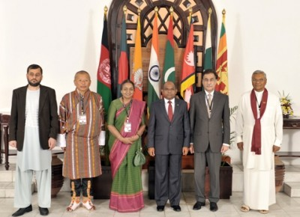
The office of the Speaker of National Assembly was supported to participate in and present an input on MDGs achievements at 7th SAARC Speakers and Parliamentarians Conference in Maldives. Leading a six-member delegation to the conference, the Speaker of the National Assembly Sardar Ayaz Sadiq presented a substantial input on SAARC countries’ support and status on MDGs.

- Computerized solution to process Questions at NA
A computerized solution has been introduced in the National Assembly to automate the questions of parliamentarians during the sessions. Installed at the Questions Wing, the purpose of the solution is to introduce greater transparency to the process of tabling Questions in the National Assembly submitted.

- Bills Tracking Software Developed for Senate
The project developed a Bills-Tracking Software for the Legislative Wing of the Senate Secretariat. The comprehensive software is designed to facilitate the smooth process of Bills tabled at the upper House and keep an updated record of their current status. The system was developed by the project’s IT team.

- LoA with Senate to install Wi fi facility
To provide technological assistance to legislators, UNDP and the Secretariat of the Senate of Pakistan also entered into an agreement to provide a Wi fi system at the Senate Premises. Initiated upon the request of the Senate Secretariat, the project—executed through a Letter of Agreement (LoA)—is part of UNDP’s continued assistance to the Senate Secretariat for provision of latest technology meant to support enhanced parliamentary functions.

- NA official attends international parliamentary forum
Opportunities to have international exposure contribute a great deal in capacity enhancement. Hence, the project provided logistical support to an official of the National Assembly Secretariat to take part in Commonwealth Youth Parliament. The event was held from 2-8 November in Mmbatho, South Africa.

- Provision of IT equipment to Senate Secretariat
Upon the request of Senate Secretariat, the Project also procured different IT equipment to be handed over in January 2015. The provision of equipment is part of UNDP’s efforts to enhance the functional capacities of parliamentary secretariats for effective support to lawmakers. The equipment include 07 (seven) laptops and 01 (one) multimedia to be given to different branches of Senate.

Overall Output Status (mark the output on the scale of 1 to 5 as per the following criteria):
Exemplary (5)  ***** | High (4)  **** |  | Satisfactory (3)  ✔ |  | Poor (2)  ** |  | Inadequate (1)  *
The project is expected to over-achieve targeted outputs and/or expected levels of quality, and there is evidence that outputs are contributing to targeted outcomes | The project is expected to over-achieve targeted outputs and/or expected levels of quality |  | The project is expected to achieve targeted outputs with expected levels of quality |  | The project is expected to partially achieve targeted outputs, with less than expected levels of quality |  | Project outputs will likely not be achieved and/or are not likely to be effective in supporting the achievement of targeted outcomes
Means of Verification
- Paper on MDGs
- Letter/certificate acknowledging the installation of the Kiosks
- Project completion/progress report
- Software developer’s report

Project Output 2:
Independent and professional Parliamentary Administration support the work of the National Assembly and enhance capacities to provide legislative services to Members and committees.

Indicator(s):  Legislative drafting: availability of legislative drafting curriculum. |  | Baseline:  Federal and Provincial Assemblies lack in-house legislative drafting expertise |  | Target(s):  Introduce/develop short and long-term curriculum on parliamentary systems including educational material. |  | Achievement(s):  Establishment of Senate Think Tank;  Support to Senate in organising 6th Plenary Session of Asian Parliamentary Assembly
Description of output level results achieved in 2014:

- Senate Think Tank established
UNDP, during year 2014, continued its assistance to the parliament as well as the secretariat and has proudly been associated with the efforts towards the establishment of a Permanent Think Tank—Senate Forum for Policy Research. Continuing its prompt response every time the key meetings of the Forum have been held, the parliamentary support project supported the forum in holding its meetings regularly. Mainly held in Islamabad, the purpose of the meetings had been to finalise the proposal for the Forum. The efforts yielded success when in October, the Senate unanimously approved the establishment of the Forum by adopting amendments in Senate Rules of Procedure and Conduct of Business 2012.

For the Forum Secretariat, two important units of the Senate have been merged (the legislative drafting and the research units). Their functions would now be performed by the Forum Secretariat, guided and supervised by the Forum members. This is expected to enhance the quality of research and the legislative drafting in the House, as well as involving sitting and former Senators to supervise this process.

Overall Output Status (mark the output on the scale of 1 to 5 as per the following criteria):
Exemplary (5)  ***** | High (4)  **** |  | Satisfactory (3)  ✔ |  | Poor (2)  ** |  | Inadequate (1)  *
The project is expected to over-achieve targeted outputs and/or expected levels of quality, and there is evidence that outputs are contributing to targeted outcomes | The project is expected to over-achieve targeted outputs and/or expected levels of quality |  | The project is expected to achieve targeted outputs with expected levels of quality |  | The project is expected to partially achieve targeted outputs, with less than expected levels of quality |  | Project outputs will likely not be achieved and/or are not likely to be effective in supporting the achievement of targeted outcomes
Means of Verification
- Press Release / News Item / Order of the day about Senate Forum
- Nest Reports of 6th Plenary Session of Asian Parliamentary Association

Project Output 3:
Selected National Assembly and Senate committees empowered to more effectively scrutinize legislation and executive action, and promote public input into their work.

Indicator(s):  Research and policy support: directory of experts published, number of briefings for committees on selected policy issues  Public hearings: number of committees that hold at least 1 public hearing per year on policy issues, number of committee reports on policy issues where it is clear evidence that public inputs have been included  Oversight independent institutions: number of committees producing report with project technical support |  | Baseline:  New committees recently formed, no experience of new MPs on committee work, no practice on work planning by committees, lack of standard templates for committee documentation.  NA and Senate lack specialised/policy level legislative research staff, inconsistent and informal interaction with experts/academia.  Non-focused oversight of independent institutions, new institutions report to Parliament as per 18th Amendment, but no or unclear procedure exist |  | Target(s):  Selected Committees of the federal parliament are equipped with database of experts and SoP documents on public interaction.  Committees are able to identify gaps in their regular functioning and start reviewing their working strategy/methods. |  | Achievement(s):  Publishing the Report of Senate Standing Committee on Foreign Affairs;
Description of output level results achieved in 2014:

Very little was achieved under this output due to a request from the National assembly to delay such work until after its new 5-Year Strategic Plan has been approved. During Phase IV UNDP will only work with committees relevant to MDGs and the focus will be on improving committees oversight of progress towards achieving MDG targets.

- Senate Foreign Affairs Committee Publishes its Report
With the support of UNDP, the Senate Standing Committee on Foreign Affairs published the Report of the Public Hearing it held jointly with the Foreign Affairs Standing Committee of the National Assembly in 2013. The Public Hearing on the topic of “Future of SAARC in the Context of Pakistan-India Relations” was also organised with the support of UNDP.
Overall Output Status (mark the output on the scale of 1 to 5 as per the following criteria):
Exemplary (5)  ***** | High (4)  **** |  | Satisfactory (3)  ✔ |  | Poor (2)  ** |  | Inadequate (1)  *
The project is expected to over-achieve targeted outputs and/or expected levels of quality, and there is evidence that outputs are contributing to targeted outcomes | The project is expected to over-achieve targeted outputs and/or expected levels of quality |  | The project is expected to achieve targeted outputs with expected levels of quality |  | The project is expected to partially achieve targeted outputs, with less than expected levels of quality |  | Project outputs will likely not be achieved and/or are not likely to be effective in supporting the achievement of targeted outcomes
Means of Verification

- Report of Public Hearing of Senate Foreign Affairs Committee

Project Output 4:
Increased cross- party co-operation between men and women parliamentarians on issues of concern to the women, and the incorporation of gender issues into the work of parliamentary committees.
Indicator(s):  Women’s Caucus: % of women MPs satisfied with quality of orientation and briefings, number of annual work plans implemented by the caucus. |  | Baseline:  Most newly elected women MPs lacking knowledge of existing Caucus and gender/women’s rights issues.  Absence of institutional mechanism/tools for gender analysis by standing committees |  | Target(s):  Women parliamentarians are able to focus on active on legislative/oversight business on issues related to women and marginalised segments of society through orientation and networking mechanisms. |  | Achievement(s):  Women Caucuses of four provincial assemblies formed; Agenda setting workshop of Punjab Caucus held;  Draft strategic Plans of Provincial Caucuses developed;
Description of output level results achieved in 2014:

- NA, WPC supported to host CPA-UK
United Nations Development Program supported the Women’s Parliamentary Caucus and the Office of the Speaker of the National Assembly in hosting Commonwealth Parliamentary Association-UK (CPA-UK) and Women Parliamentary Caucus (WPC) Trilateral Dialogue in Islamabad.

- Pre-caucus Orientation for Women MPAs of Sindh
The efforts of the Project team to form provincial caucuses yielded results first in Sindh where a resolution for establishing the Women’s Parliamentary Caucus was passed in February. Earlier, apart from holding meetings, an orientation session on Gender Mainstreaming was also organised for women MPAs in the province.

- Initial Legislative Agenda-setting Workshop in Punjab
Support was provided in establishing the women caucus of the Punjab Assembly. The project team helped the Punjab Women’s Caucus in setting their Legislative Agenda for the year. The two-day event was held in April in which the members of the caucus set the goals and agenda of the forum through mutual consultation. UNDP also provided expertise of a well-known gender specialist, Dr. Fouzia Saeed, to conduct the workshop and help the women legislators in setting their agenda. Furthermore, the provincial assembly of Punjab has taken the lead in terms of notifying the caucus and providing space for establishing its secretariat. In total 118 participants took part in the two-days’ workshop.

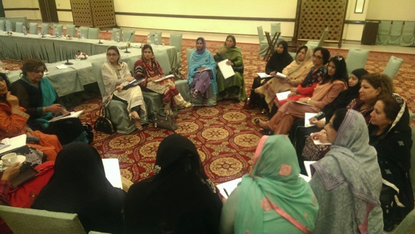
Speaking on the occasion, Azma Bokhari, the Convener of the Provincial Caucus announced the names of the women MPAs who were declared the focal points for their respective Districts and coordinators at Divisional levels to apprise the Caucus on existing women-specific issues. She hoped that the women members of the provincial assembly would be able to achieve the goal of promoting the cause of the women together as a one team. She also thanked UNDP on facilitating the event adding that the agency had always been very supportive to the women MPAs.

- Strategic Planning Workshop for Sindh, Balochistan WPCs
The first strategic planning exercise for the Women Parliamentary Caucuses of Sindh and Balochistan was conducted in the month of September.

- South Asia Exchange Meeting in Nepal
The National Policy Adviser of the project attended a South Asia Exchange meeting held in Kathmandu, Nepal, in July to effectively promote women’s leadership and political participation at all levels. The meeting was hosted by the Women’s Parliamentary Caucus, National Commission on the Status of Women Pakistan and National Women Commission Nepal with the support of UNDP Pakistan. As many as 53 delegates participated in the meeting from Afghanistan, Bangladesh, Bhutan, India, Maldives, Nepal, Pakistan and Sri Lanka.

- Roundtable involving Civil Society and WPC Punjab
A roundtable discussion with civil society was held on October 29, 2014 in Lahore. The objective of the meeting was to review the functions of Women Parliamentary Caucus (WPC), Punjab and get suggestions on the issues that need to be addressed by (WPC). The discussion was aimed at highlighting some of the key issues and prioritizing them for legislative debate in the provincial assembly. A total of 26 participants attended representing various institutions including civil society, Women Chamber of Commerce, teachers, and media persons.

- Strategic Planning for KPK and Punjab WPCs
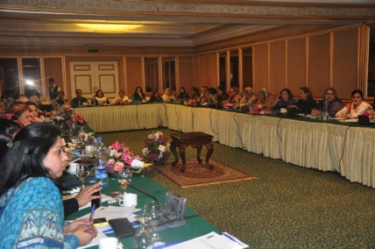
The Project held the first of the strategic planning workshops for the Women Parliamentary Caucuses of Khyber Pakhtunkhwa and the Punjab during the month of November. Held from 08-10 November in Bhurban, the workshop was attended by 65 participants from both the provincial caucuses.

Renowned gender expert and activist Dr. Farzana Bari gave a detailed account and historical perspective of women’s movement and political participation in Pakistan.

Participants were taken through the fundamental steps of Strategic Planning and then split into various groups to conduct group work which included conducting SWOT analysis and developing mission statements and strategic goals.

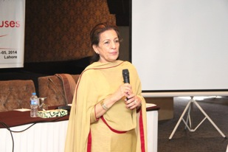
- Joint Strategic Planning for Provincial WPCs
A combined Strategic Planning and Agenda Setting Workshop was held for all Provincial Women Caucuses in Lahore from 3-5 December. All four Provincial WPCs presented their draft Strategic Plans for review during the three day event.

On the occasion, Ms. Marvi Sirmed shared that UNDP was planning to hold a National Convention of Women Parliamentarians by March 2015.

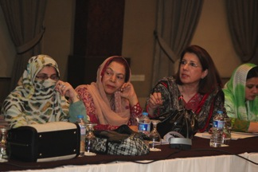
Ms. Marvi Sirmed added that the Federal Women Parliamentary Caucus had already set their theme for the year 2015, for which they were in the process of developing awareness material in the form of a table calendar and a planner. She urged the Provincial Caucuses to think on the same lines and set their themes for the year. On that, different suggestions from women on as to what theme should be appropriate for their respective caucuses came forward. Some of the suggestions included:

- Health Issues of Women
- Early/forced marriages
- Women Trafficking
- Domestic violence

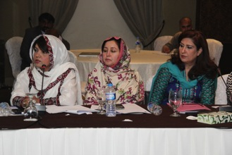
Presentations from Provincial Caucuses on their earlier-developed draft Rules of Procedures was one of the main highlights of the event. The first of the presentation was delivered by Ms. Shahla Raza, Deputy Speaker of Sindh Assembly and Patron of the Provincial Women Caucus, Sindh. Ms. Amina Sardar, MPA from KPK, presented the Objectives, Vision, Mission and organogram of the Women Caucus of Khyber Pakhtunkhwa Assembly. Ms Raheela Durrani, MPA from Balochistan, gave a presentation on the initiatives taken at the Balochistan Assembly on women-related issues adding that a Bill on Domestic Violence was recently tabled in the Provincial Assembly.

- Support to Thematic Campaign on Violence Against Women
The Project also supported the Federal Women’s Caucus in its 16-day campaign on Violence Against Women (November 26 to December 10).

The support has mainly been on developing awareness-raising material on the theme—violence against women. In this connection, table calendars, posters and diary planners were developed for dissemination for the Federal Women Parliamentary Caucus.
Overall Output Status (mark the output on the scale of 1 to 5 as per the following criteria):
Exemplary (5)  ***** | High (4)  **** |  | Satisfactory (3)  ✔ |  | Poor (2)  ** |  | Inadequate (1)  *
The project is expected to over-achieve targeted outputs and/or expected levels of quality, and there is evidence that outputs are contributing to targeted outcomes | The project is expected to over-achieve targeted outputs and/or expected levels of quality |  | The project is expected to achieve targeted outputs with expected levels of quality |  | The project is expected to partially achieve targeted outputs, with less than expected levels of quality |  | Project outputs will likely not be achieved and/or are not likely to be effective in supporting the achievement of targeted outcomes
Means of Verification
- Attendance sheets of events
- Notifications of caucuses’ formation
- Report of the Workshop / Draft Strategic Plans of each WPC
- Pictures

Project Output 5:
National Assembly engage with the people of Pakistan more transparently and effectively.
Indicator(s):  Unfunded |  | Baseline:  Unfunded |  | Target(s):  Unfunded |  | Achievement(s):  Unfunded
Description of output level results achieved in 2014:

- Results related to this output were not pursued due to lack of funding.
Overall Output Status (mark the output on the scale of 1 to 5 as per the following criteria):
Exemplary (5)  ***** | High (4)  **** |  | Satisfactory (3)  *** |  | Poor (2)  ** |  | Inadequate (1)  ✔
The project is expected to over-achieve targeted outputs and/or expected levels of quality, and there is evidence that outputs are contributing to targeted outcomes | The project is expected to over-achieve targeted outputs and/or expected levels of quality |  | The project is expected to achieve targeted outputs with expected levels of quality |  | The project is expected to partially achieve targeted outputs, with less than expected levels of quality |  | Project outputs will likely not be achieved and/or are not likely to be effective in supporting the achievement of targeted outcomes
Means of Verification
None / NA

Project Output 6:
Provincial Assemblies more effectively oversee progress in achievement of MDGs, gender equality and devolution process; and promote public input into their committee work.

Indicator(s):  MPAs orientation: % of MPAs satisfied with quality of orientations in their feedback  Women’s Caucus: % of women satisfied with quality of orientation and briefings, number of annual workplans implemented by each of the caucuses; strategy for gender analysis by committees adopted, progress towards implementation.  Strategic planning: 5-year strategic plan 2014-2018 finalised, number of annual action plans implemented, SP mid-term review report, number of strategic planning common issues discussed at Speakers’ Conference or Secretaries’ Forum or similar exchange venues. |  | Baseline:  Limited experience of MPs on committee work including oversight of MDGs, gender equality, devolution process;  Outdated Strategic Plan 2009-10 was produced in 2008 for all PAs, no implementation. |  |  | Target(s):  Working capacities of provincial parliaments and secretariats enhanced through MPA/staff orientations and gender-related institutions through establishing caucuses. | Achievement(s):  Parliamentary Task Forces on MDGs at Federal Parliament and Provincial Assemblies formed; National Parliamentary Conference on MDGs held; Strategic Planning Sessions for MDG Task Forces held
Description of output level results achieved in 2014:

- National Parliamentary Conference on MDGs held
The first National Parliamentary MDGs Conference was held in Islamabad on 2-4 June 2014. UNDP was the lead partner for the three-day conference. The workshop included special thematic sessions on each of the MDGs in which the participants not only discussed the existing progress and achievements, but also charted out their own future course of action and post-2015 agendas on sustainable development goals. As many as 150 participants took part in the three-day event.
The conference was called in response to UNDP research indicating that Pakistan was off-track on most of its MDG indicators. The conference provided the legislators an opportunity to review the current status of targets under each MDG and to determine a way forward.

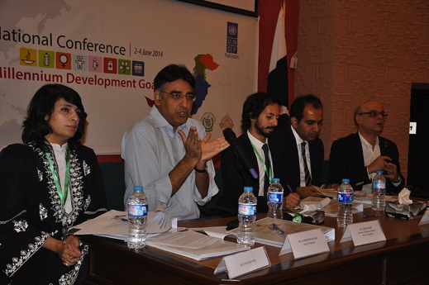
Sardar Ayaz Sadiq, the Speaker of National Assembly of Pakistan, formally inaugurated the Conference. The Speaker called for the engagement of all parliamentary task forces to reinforce efforts in achieving the MDGs. He suggested that provincial lawmakers constitute committees in their respective legislatures to perform effective oversight of the provincial executives on MDGs.

On the closing day of the conference participants presented their proposed Parliamentary action plans to accelerate work on achieving the Development Goals in Pakistan. The parliamentarians from across the country developed their National Action Plans supporting the achievement of each of the MDGs in their respective geographic region(s). That marked the first time that the National and Provincial Task Forces met to agree on a nationwide approach to the MDGs.

- Strategic Planning Workshops for MDG Task Forces
Continuing its support to the Federal and Provincial Parliamentary Task Forces on MDGs, and to develop their capacity, UNDP organised two separate Strategic Planning Workshops in September and December. Held in Bhurban, the first workshop was attended by the members of Federal, KP, Balochistan, AJK and GB Task Forces. The second of the Strategic Planning Workshops involving Sindh and Punjab MDG Task Forces.
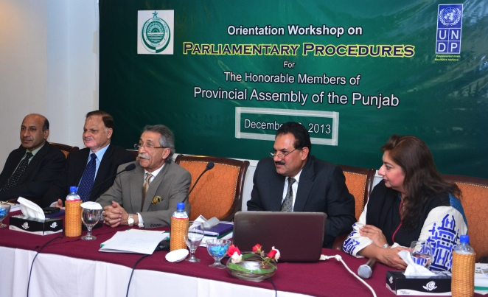

- Punjab MPAs’ orientation on House Rules
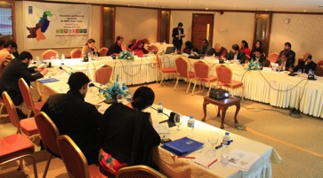
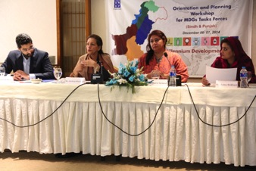
After a series of consultations with the members and secretariat officials of the provincial assembly of the Punjab, UNDP organised an orientation session for the Members of the Punjab Assembly in Lahore on the subject of Question Hour. During the consultations it emerged that the members need orientation on the House rules in different phases. That is precisely why the topic of Question Hour was chosen to start with. The members initially faced a lot of difficulties about the process of tabling and drafting questions.

The event, in which a former Speaker of the Punjab Assembly Choudhry Muhammad Anwer Bhinder was the Lead Facilitator, proved to be a very useful learning opportunity for the members of the provincial assembly. The sitting Speaker Rana Muhammad Iqbal Khan inaugurated the workshop.

- Orientation on Budget Processes
A knowledge-sharing workshop on budget processes and analysis for members of the Punjab Assembly was held in May. The purpose of the workshop was to familiarize the members of the Punjab Assembly about the rules, processes and roadmap of the budget as well as briefing them about the main income and expenditure avenues for the Province. Dr. Pervez Tahir, a well-known economist and former Chief Economist of Pakistan, was engaged to be the lead resource person for the workshop while the Director General (Parliamentary Affairs & Research), Punjab Assembly, Mr. Inayatullah Lak, was invited to explain the parliamentary rules and procedures relevant to budget presentation and debate etc. As many as 106 participants took part in the event.

Mr. Inayetullah Lakk, gave a briefing on the budget procedure according to the existing Rules of Procedures in the Assembly. The meeting ended with a vote of thanks from Mr. Amir Goraya, head of Democratic Governance, UNDP.

- Women lawmakers interact with rural women in Islamabad
Prominent women parliamentarians from the federal and provincial parliaments attended a forum to interact with 1200 rural women from across Pakistan. The gathering was part of the International Day for Rural Women celebrations observed on October 15 each year. UNDP partnered with Potohar Organisation for Development Advocacy (PODA), a local NGO based in Islamabad. A host of issues faced by rural women ranging from violence to economic contribution of rural women came under discussion.

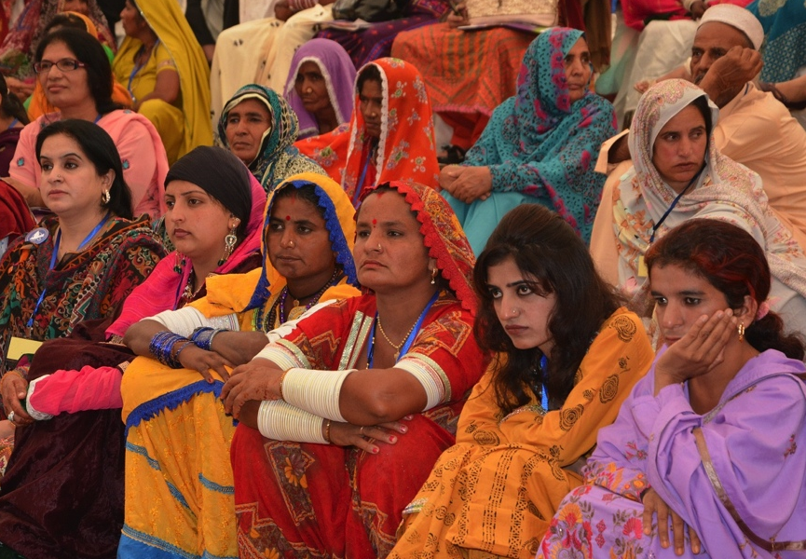
- Urdu Translation of KP Assembly RoPs
During the project’s consultative meetings to chart out the strategy identifying support areas to the provincial assembly of Khyber Pakhtunkhwa, the Provincial Assembly requested the Project team for support in getting the latest rules of the provincial assembly translated into Urdu since the majority of the members faced difficulties in understanding the existing document. The Project engaged an expert of the subject having decades of experience of working with the Pakistan Academy of Letters for the task. The newly-translated rules have been shared with the Assembly Secretariat for review and finalization.

- Seminar with Punjab Press Gallery Association
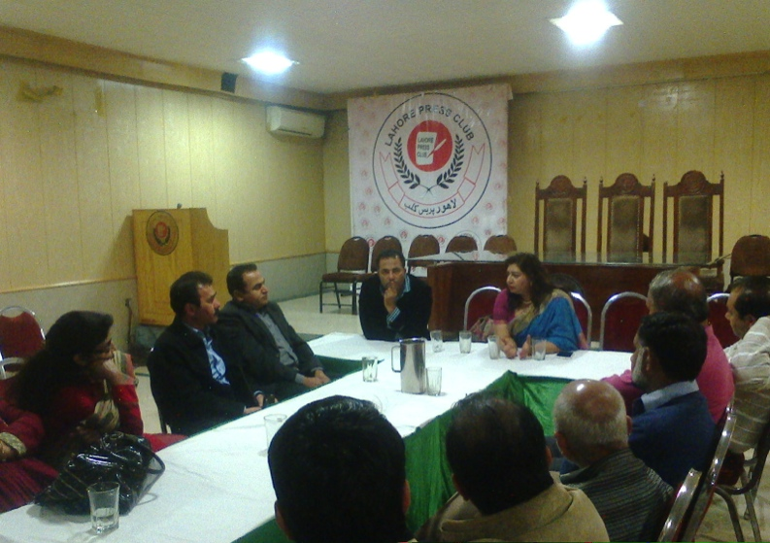
As a part of the envisaged plan for capacity-building of the media persons covering parliamentary proceedings, UNDP team held a preliminary discussion with the members and office bearers of Press Gallery Association, the forum of journalists covering the Punjab Assembly. Held on March 8 at Press Club Lahore, the discussion was intended to assess the needs of the journalists with regards to training and capacity building. The dialogue also paved way to drafting an initial plan for training and capacity building of media persons in Punjab.

Overall Output Status (mark the output on the scale of 1 to 5 as per the following criteria):
Exemplary (5)  ***** | High (4)  **** |  | Satisfactory (3)  ✔ | Poor (2)  ** |  |  | Inadequate (1)  *
The project is expected to over-achieve targeted outputs and/or expected levels of quality, and there is evidence that outputs are contributing to targeted outcomes | The project is expected to over-achieve targeted outputs and/or expected levels of quality |  | The project is expected to achieve targeted outputs with expected levels of quality | The project is expected to partially achieve targeted outputs, with less than expected levels of quality |  |  | Project outputs will likely not be achieved and/or are not likely to be effective in supporting the achievement of targeted outcomes
Means of Verification
- Event Report / News clippings
- List of Participants / Attendance sheet
- Resource material
- Final Report of the Activity/Assessment
- Draft Strategic Plan

- Lessons Learnt

In order to manage and strengthen its relationship with each legislative institution, the project needs to develop AWPs that are less aspirational and firmly aligned with a) available technical and financial resources and b) the realities of the donor environment. The 2014 AWP was overly ambitious resulting in too many unfilled promises to legislative institutions, particularly the Provincial Assemblies. This undermined relationships. There also needs to be a stronger focus on providing technical assistance as opposed to operational support.

The strategy for Phase IV, and the AWP 2015, reflects a shift to a more modest approach, anchored in more realistic areas of technical assistance that can generate desired results. By adopting a more issues based approach (women empowerment and strengthening parliamentary engagement with development policy agenda) the intent is to give the project a more coherent narrative in terms of what results it intends to achieve.

Data collection methods need to be improved in order to demonstrate whether or not the project is making progress towards stated objectives.

- The way forward/ key Priorities FOR 2015

Priority Actions

The overarching strategic goal during Phase 4 of UNDP’s Parliamentary Strengthening Project (January 2015 – December 2017) is to develop institutional and individual capabilities vis-à-vis the federal and provincial assemblies - the intent is to implement activities which will deliver gradual and consistent institutional change over the next few years. It will do this by equipping legislators and Secretariats with the resources and technical expertise that are needed to improve the legislative, oversight and representation functions of each assembly.

The strategy is structured around four core outputs (listed in the box below) which, as mentioned above, are the result of extensive consultations with stakeholders in the federal and provincial assemblies. All are intended to empower parliamentarians and enhance parliamentary administration. Whilst the objectives are broadly the same for the federal and provincial assemblies, the activities conducted under each objective are customized for each legislative assembly to optimize their strategic relevance, and alignment with the specific capacity building needs of each legislative assembly. This reflects the divergence in priorities and technical assistance requirements evident from the extensive consultations that took place.

Output1: Strengthen the institutional and democratic performance of the Senate, the National Assembly and the Provincial Assemblies

Output 2: Enhanced participation, and empowerment of women in parliamentary and electoral processes.

Output 3: Legislators and staff at the Secretariat have the knowledge and technical skills to improve legislative engagement with development policy agendas (PRSP, MDGs/SDGs).

Output 4: Increased civic engagement, particularly among youth, with parliamentary institutions and processes.

Output 1 – Strengthen the institutional and democratic performance of the Senate, the National Assembly and the Provincial Assemblies

UNDP intends to accomplish this objective over the next few years by focusing on a) the implementation of the 18th Amendment b) assisting the development of ICTs (information and communication technologies) capabilities c) developing the technical skills of legislators and Secretariat staff and d) providing support to enhance the operational and administrative capacity of the Secretariat.
With regards to the 18th amendment, significant effort will be dedicated towards raising awareness on its scope and implications, equipping the assembly with the knowledge and skills to legislate effectively in the devolved areas, as well as providing technical and policy analysis support to standing committees covering devolved issues.

Broader capacity development support will be provided through policy and research assistance from UNDP, the dissemination of knowledge products and best-practice from UNDP parliamentary programming in other countries, as well as exchange visits to parliaments outside Pakistan.

Core Priorities for 2015:

- Develop innovative platforms to enable easier access to the business of the Assemblies (e.g the development of bill tracking systems).
- Develop digital libraries and databases to improve the knowledge products available to legislators.
- Trainings on Rules of Procedure, technical policy issues, budgetary oversight, parliamentary practices and tools to enhance parliamentary oversight (Questions, Point of Order, Calling Attention Notices).
- Provide human resource and technical support to Secretariat staff.

Output 2 – Enhanced participation and empowerment of women in parliamentary and electoral processes

UNDP is currently working with the Women’s Parliamentary Caucuses at the Federal and Provincial levels, to develop their respective strategic plans. UNDP plans to provide the WPCs with technical assistance to implement their plans, establish a Secretariat for the WPCs, and provide on-going advice and support for the WPCs legislative and advocacy initiatives. Quarterly trainings will also be provided to develop the technical skills of WPC members and regular knowledge seminars will be held with key stakeholders to develop the policy knowledge and expertise of WPC members

Core Priorities for 2015:
- Trainings on gender budgeting, rules of procedure and developing monitoring and evaluation mechanisms to measure the implementation of strategic plans.
- Organize seminars for WPCs, CSOs and academics on specific issues relevant to women empowerment
- Host trainings for MNAs , Senators, and MPAs on gender self-awareness and gender sensitization
- Develop Strategic Communications Plans for each WPC & develop a handbook on media engagement

Output 3 – Legislators and Secretariat staff have the knowledge and technical skills to improve legislative engagement with development policy agendas (PRSPs/MDGs/SDGs)

Achieving the Millennium Develop Goals (MDGs) represents a top priority for Pakistan. Progress against the targets set under each goal remains a challenge. Following the 18th Amendment, responsibility for achieving most of the MDGs now rests with the Provincial authorities. This poses a significant challenge and progress will require significant legislative engagement, monitoring and oversight from the Provincial Assemblies. UNDP plans to work with Provincial MDG Taskforces to build their technical capacity and develop strategic plans that will guide legislative engagement in the MDG process. Policy analysis support will be provided as well as data and tools to help Committee Members track progress against MDGs that fall within their respective areas of scrutiny.

Core Priorities for 2015:
- Assist the development and implementation of Strategic Plans for each MDG TF
- Train subject matter experts in the TF on each MDG policy areas within each Assembly.
- Technical assistance and trainings to strengthen committees’ oversight of development policies (knowledge development, budgetary analysis, expenditure reviews, tracking progress against national, provincial and district targets etc)
- Conduct orientation trainings for MPAs on MDGs/SDGs
- Conduct pre and post budget orientation trainings for MPAs

Output 4 - Increased civic engagement, especially among the youth, with parliamentary institutions and processes.

As elected institutions that represent the people, the legislative branch needs to ensure mechanisms are in place for citizens to actively engage in the legislative process. This is vital to sustain and strengthen public confidence in the parliamentary system, and to improve service delivery. Each legislative institution needs to develop tools and mechanisms to enhance citizens’ engagement with its work, especially among youth. This will take time but UNDP recommends that this be a core component of each legislature’s institutional development agenda over the next four years

Core Priorities for 2015:
- Develop communications and outreach strategies with a focus on youth.
- Develop a media handbook for MPAs and provide media trainings for legislators.
- Train local journalists on how to report on, and analyse, parliamentary proceedings

Annex: AWP based Reporting Matrix
EXPECTED OUTPUTS  And baseline, associated indicators and annual targets |  | PLANNED ACTIVITIES (as per AWP) | Activity Status  Completed, Ongoing, , Cancelled | AWP Budget ($) | Expenditure ($) | % Delivery
Project Output 1: Governance structures of National Assembly and Senate more effectively perform their mandates and successfully conduct strategic institutional development.  Indicators: Speakers’ Conference: number of recommendations adopted  Council of Chairpersons: number of recommendations adopted and progress in implementation, regularity of meeting  Parliamentary integrity: recommendations for Code of Ethics/Conduct adopted  Baseline: Speakers’ Conference a conventional forum that meets less than once a year on average and lacks structured operation.  RoP provides for Council of Chairpersons but lacks structured operation.  No. Code of Ethics/Conduct in place for MPs or staff.  Targets: Speakers’ Conference functioning regularly holding at least 2 meetings a year.  Council of Chairpersons established.  Parliamentary Staff's and elected representatives’ focus is to make parliament a more independently working institution through awareness raising sessions. |  | 1.1 Activity : MNA have enhanced knowledge on parliamentary practice through targeted orientation sessions.  Actions:  -Pre Budget session for the members of NA & Senate Secretariat  - Support to National Assembly on producing & publishing of Convention of Women Parliamentarians report-  - Establishment of high powered internet facility and equipment in the Senate Secretariat Premises.  s |  | 19,500.00 | 19,187.00 | 98.39 %
Project Output 2: Independent and professional Parliamentary Administration support the work of the National Assembly & Senate to enhance capacities to provide legislative services to Members and committees.  Independent and professional Parliamentary Administration support the work of the National Assembly and enhance capacities to provide legislative services to Members and committees.  Indicators:  Legislative drafting: availability of legislative drafting curriculum  Baseline:  Federal and Provincial Assemblies lack in-house legislative drafting expertise.  Targets  Introduce/develop short and long-term curriculum on parliamentary systems including educational material. |  | 2.1. Activity : Technical & Institution Support to Senate & National Assembly  - Support to National Assembly of Pakistan for organizing High Level meeting of Women Parliamentarians from UK & Afghanistan.  - Support to National Assembly in hosting  commonwealth Parliamentary Association  UK-(CPA-UK) Trilateral Dialogue.  - Computerized Solution to Question System -  for National Assembly  - Support to Senate Secretariate for 6th Plenary  Session of Asian Parliamentary Assembly .  -Support to Senate staff for participation in CPA Session |  | 269,660.00 | 269,288 | 99.86 %
Project Output 3: Selected National Assembly and Senate committees empowered to more effectively scrutinize legislation and executive action, and promote public input into their work.  Indicators: Role of Committees:  Research and policy support: directory of experts published, number of briefings for committees on selected policy issues  Public hearings: number of committees that hold at least 1 public hearing per year on policy issues, number of committee reports on policy issues where it is clear evidence that public inputs have been included  Oversight independent institutions: number of committees producing report with project technical support  Baseline: New committees recently formed, no experience of new MPs on committee work, no practice on work planning by committees, lack of standard templates for committee documentation.  NA and Senate lack specialized/policy level legislative research staff, inconsistent and informal interaction with experts/academia.  Non-focused oversight of independent institutions, new institutions report to Parliament as per 18th Amendment, but no or unclear procedure exist  Targets: Selected Committees of the federal parliament are equipped with database of experts and SoP documents on public interaction.  Committees are able to identify gaps in their regular functioning and start reviewing their working strategy/methods. |  | 3.1. Activity t: Committee report produced and published and used as a reference document by parliamentary committees.  - Printing & publishing of Senate Standing Committee reports on Foreign Affair  - Printing & Publishing of NA Standing Committee report Reports  - Printing & Publishing rules of Procedure. |  | 2,500.00 | 2,392.00 | 95.68 %
Project Output 4: Increased cross- party co-operation between men and women parliamentarians on issues of concern to the women, and the gender dimension is considered in the work of parliamentary committees.  Indicators: Women’s Caucus: % of women MPs satisfied with quality of orientation and briefings, number of annual work plans implemented by the caucus.  Baseline: Most newly elected women MPs lacking knowledge of existing Caucus and gender/women’s rights issues.  Absence of institutional mechanism/tools for gender analysis by standing committees.  Targets: Women parliamentarians are able to focus on active on legislative/oversight business on issues related to women and marginalized segments of society through orientation and networking mechanisms.  Effective networking mechanism between women legislators at federal, provincial levels and also with other regional women lawmakers established. |  | 4.1. Activity : Development and adoption of Women’s Caucus strategic plan and annual work plan.  - Orientation Session on Gender Mainstreaming |  | 1,000.00 | 7,28.00 | 72.80 %
Output 5: National Assembly engage with the people of Pakistan more transparently and effectively. |  |  |  | 0.00 | 0.00 | 0.00 %
Output 6: Provincial Assemblies more effectively oversee progress in achievement of MDGs, gender equality and devolution process; and promote public input into their committee work.  Indicators: MPAs orientation: % of MPAs satisfied with quality of orientations in their feedback  Women’s Caucus: % of women satisfied with quality of orientation and briefings, number of annual work plans implemented by each of the caucuses; strategy for gender analysis by committees adopted, progress towards implementation.  Strategic planning: 5-year strategic plan 2014-2018 finalized, number of annual action plans implemented, SP mid-term review report, number of strategic planning common issues discussed at Speakers’ Conference or Secretaries’ Forum or similar exchange venues.  Baseline: Newly elected MPAs lacking understanding of parliamentary practice/business.  New committees recently formed or are yet to be formed at provincial level, limited experience of MPs on committee work including oversight of MDGs, gender equality, devolution process; limited use of public hearings due to lack of knowledge/interest.  Women’s Caucus: KP PA has made significant progress in forming Caucus, Sindh and Punjab will form in a few months, Balochistan will soon establish a Caucus/Committee; no previous experience with such structures or committees consideration of gender issues into their work.  Outdated Strategic Plan 2009-10 was produced in 2008 for all PAs, no implementation.  Targets: Working capacities of provincial parliaments and secretariats enhanced through MPA/staff orientations and gender-related institutions through establishing caucuses. |  | 6.1. Activity : New MPAs have enhanced knowledge on parliamentary practice through targeted orientation sessions.  Actions:  - Orientation Sessions on Rules of Procedures |  | 10,000.00 | 9,179.00 | 91.79 %
 |  | 6.2. Activity : Development/agreement on proposal for “MDG Resource Facility” leads to establishment of the facility.  Actions:  - National MDG workshop  - Workshops on National Action Plan of MDGs for MDGs Task fierce Members KPK, Balochistan, AJK & Gilgit Baltistan  - Workshops on National Action Plan of MDGs for MDGs Task force Members Punjab & Sindh  - Workshop on National Action Plan of MDGs  - Publishing & Printing of MDGs reports into different languages  - Research Study on Legislative Gaps |  | 126,758.00 | 125,380.00 | 98.91 %
 |  | 6.3. Activity : PAs Women’s Caucus strategic plan and annual work plan developed and adopted through sensitization of women and selected committees with regard to gender and women’s issues.  - Hire Strategic Planning Expert |  | 11,000.00 | 10,610.00 | 96.45 %
 |  | 6.4. Activity : Regular interface mechanism with provincial assemblies developed.  - Strategic Planning Workshops for the member of WPCs Balochistan & Sindh  - Strategic Planning Workshop for the members of WPC KPK & Punjab.  - Follow-up workshop on Strategic Planning for WPC members Sindh & Balochsitan  - WPC Briefing Sessions  - Women Caucus Legislative Agenda Planning Consultation  - National Women's Conference  - Establishment of Women Parliamentary Caucuses offices  - Hire Gender Expert in Strategic Envisioning of Women's Parliamentary Caucus |  | 127,267.00 | 126,358.00 | 99.29 %
Project Output 7:  Operation Management . |  |  |  | 232,315.00 | 231,344.00 | 99.58 %
 |  |  | Grand Total= | 800,000.00 | 794,466.00 | 99.31 %

Outcomes describe the intended changes in development conditions that result from the interventions of governments and other stakeholders, including international development agencies such as UNDP. They are medium-term development results created through the delivery of outputs and the contributions of various partners and non-partners. Outcomes provide a clear vision of what has changed or will change globally or in a particular region, country or community within a period of time. They normally relate to changes in institutional performance or behavior among individuals or groups. Outcomes cannot normally be achieved by only one agency and are not under the direct control of a project manager.
Outputs are short-term development results produced by project and non-project activities. They must be achieved with the resources provided and within the time-frame specified (usually less than five years).

